WEBSITE Temple

line 1: 1st Joshua sabas Nirwana
line 2: Univercity Bina Nusantara (Binus)
line 3 : Malang, East Java
line 4: joshua.nirwana@binus.ac.id
line 1: 2nd Wibrian Alfathan
line 2: Univercity Bina Nusantara (Binus)
line 3 : Malang, East Java
line 4: wibrian.alfathan@binus.ac.id
line 1: 3rd Erlan Loanel
line 2: Univercity Bina Nusantara (Binus)
line 3 : Malang, East Java
line 4: erlan.loanel@binus.ac.id

Abstract— The internet has many benefits that we can take. One of them is like a website. A website is a central place where web pages are stored. The page contains content or content from the website.
When building an ELearning website, you must first pay attention to: 1) a map of the potential of existing HR, it would be better if we were able to utilize existing HR whether it was for education, business or knowledge and news to build a good website; 2) the ability of the Human Computer Interface, namely the ability to interact between the user and the E-learning website

Keywords—Website, Interaction, Temple Djago.

Introduction
In this 4.0 industrial revolution, everyone in the world cannot be separated from the word internet. The internet has many benefits that we can take. One of them is like a website. A website is a central place where web pages are stored. The page contains content or content from the website.
Culture is a way of life that develops, is shared by a group of people, and is passed down from generation to generation. Culture is made up of many complex elements, including religious and political systems, customs, language, tools, clothing, buildings, and works of art. Well this time we talk about temples, temples are religious buildings where ancient relics originated from Hindu-Buddhist civilization. This building is used as a place of worship of the gods or glorify the Buddha.
This temple is called Djago, located in Malang, East Java. This temple is famous as majesty which is a sacred place for Buddhist people. The temples are well-set with the Tatrayana Buddhism. One of the characteristics of the Buddha Tatrayana religion is the shape of the Amoghapasa, the form of the Tatris from the early hours of the theater accompanied by its accompanists. The statue is a statue of the embodiment of the fourth king singasari named King Wisnuwarddhana, who died in 1190 Saka (1280 AD). This temple is quite unique, because the top is destroyed and only a part of it is left, according to local stories because of being struck by lightning. With an interesting website, it will make the reader want to read on and also know about its history.
With language that is easy to understand and interactions on the website are expected to make readers increasingly want to get to know this famous temple.

Metode

Reading, listening , looking
- Reading, seeing and listening are three language processes that have some of the same and different properties. The equation is that the meaning of the sentence or phrase is the same regardless of the way it is conveyed. The ease with which people can read, listen or speak differs depending on the person, task and context. While the difference between these three processes is that reading can be faster than speaking or listening, because written text can be quickly scanned in an impossible way when listening to spoken words. Listening requires less cognitive effort than reading or speaking. Written reading tends to be grammatical while oral language is often not ungrammatic. Dyslexic people have difficulty understanding and recognizing written words, making it difficult for them to write grammatical sentences and spell correctly.
- E-Learning is one of the important learning media for students. Where E-learning consists of various kinds of media and applications, both for learning resources, sharing, and social interaction through the internet network. For this reason it is necessary to apply a HCI (Human Computer Interaction) model to the website so Elearnig can be more interactive.

B. Theory
In making this website we use theories such as HTML, CSS, JAVAscript, and BOOTSTRAP languages.
1. HTML
Hypertext Markup Language (HTML) is a markup language used to create a web page, display various information in an Internet web browser and formulate a simple hypertext format written in an ASCII format file in order to produce an integrated appearance. In other words, files are created in word processing software and are stored in the normal ASCII format so that they become web pages with HTML commands. There are 3 bodies namely <html>, <head>, <body>
<html> </html> tag is the highest level element that includes every HTML page.
The <head> </head> tag stores meta information, such as the page title and charset.
The <body> </body> tag attaches all content that appears on a page.
A simple example is when we want to type or make a parangraf so we first open it<!DOCTYPE html>//membuktikan bahwa ini dokumen html
<html>untuk membuat halaman
<body>untuk isi halaman
<p>Belajar HTML Sangat sulit<\p>
</body>penutup isi halaman
</html>penutup halaman

- CSS
Cascading Style Sheet (CSS) is a rule for regulating several components in a web so that it will be more structured and uniform. CSS is not a programming language. Similarly, styles in word processing applications such as Microsoft Word can set several styles, such as headings, sub-chapters, bodytext, footers, images, and other styles to be used together in several files.
- JAVASCRIPT
JAVASCRIPT is a high-level and dynamic programming language. JS is a World wide web technology besides HTML and CSS, the function of javaScript is to help make the web more interactive and an essential part of web applications.
- BOOTSTRAP
BOOTSTRAP is a free and open CSS framework for designing website designs and web applications. The framework usually contains HTML and CSS-based design templates, forms, buttons, navigation, and other interface components. Unlike most other web frameworks, this framework only focuses on developing front-end.rancangan Program

Berikut adalah code HTML,CSS, dan JS
- Code Home

<!DOCTYPE html>
<html lang="en">
<head>
<meta charset="utf-8">
<title>Candi Djago</title>
<meta content="width=device-width, initial-scale=1.0" name="viewport">
<meta content="" name="keywords">
<meta content="" name="description">

<!-- Icon Candi -->
<link href="img/icon2.png" rel="icon2">
<link href="img/icon.png" rel="icon">

<!-- Google Fonts -->
<link href="https://fonts.googleapis.com/css?family=Poppins:300,400,500,600,700" rel="stylesheet">

<!-- Bootstrap CSS File -->
<link href="lib/bootstrap/css/bootstrap.min.css" rel="stylesheet">

<!-- Libraries CSS Files -->
<link href="lib/font-awesome/css/font-awesome.min.css" rel="stylesheet">
<link href="lib/animate/animate.min.css" rel="stylesheet">
<link href="lib/ionicons/css/ionicons.min.css" rel="stylesheet">
<link href="lib/owlcarousel/assets/owl.carousel.min.css" rel="stylesheet">

<!-- Efek CSS -->
<link href="css/style.css" rel="stylesheet">
</head>

<body>

<div class="click-closed"></div>

<!--/ Menu /-->
<nav class="navbar navbar-default navbar-trans navbar-expand-lg fixed-top">
<div class="container">
<button class="navbar-toggler collapsed" type="button" data-toggle="collapse" data-target="#navbarDefault"
aria-controls="navbarDefault" aria-expanded="false" aria-label="Toggle navigation">
<span></span>
<span></span>
<span></span>
</button>
<a class="navbar-brand text-brand" href="index.html">Candi<span class="color-b"> Djago</span></a>
<div class="navbar-collapse collapse justify-content-center" id="navbarDefault">
<ul class="navbar-nav">
<li class="nav-item">
<a class="nav-link active" href="index.html">Home</a>
</li>
<li class="nav-item">
<a class="nav-link" href="about.html">About</a>
</li>
<li class="nav-item">
<a class="nav-link" href="artefact.html">Artefact</a>
</li>
<li class="nav-item">
<a class="nav-link" href="contact.html">Contact</a>
</li>
</ul>
</div>
</div>
</nav>
<!--/ Menu /-->

<!--/ Home /-->
<div class="intro intro-carousel">
<div id="carousel" class="owl-carousel owl-theme">
<div class="carousel-item-a intro-item bg-image" style="background-image: url(img/djago.jpg)">
<div class="overlay overlay-a"></div>
<div class="intro-content display-table">
<div class="table-cell">
<div class="container">
<div class="row">
<div class="col-lg-8">
<div class="intro-body">
<p class="intro-title-top">Malang, Jawa Timur
<br> 61122</p>
<h1 class="intro-title mb-4">
<span class="color-b"> Candi</span> Djago
<br> Singhasari</h1>
</p>
</div>
</div>
</div>
</div>
</div>
</div>
</div>
<div class="carousel-item-a intro-item bg-image" style="background-image: url(img/jago1.jpg)">
<div class="overlay overlay-a"></div>
<div class="intro-content display-table">
<div class="table-cell">
<div class="container">
<div class="row">
<div class="col-lg-8">
<div class="intro-body">
<p class="intro-title-top">Malang, Jawa Timur
<br> 61122</p>
<h1 class="intro-title mb-4">
<span class="color-b">Candi </span> Djago
<br> Singhasari</h1>
</div>
</div>
</div>
</div>
</div>
</div>
</div>
<div class="carousel-item-a intro-item bg-image" style="background-image: url(img/jago2.jpg)">
<div class="overlay overlay-a"></div>
<div class="intro-content display-table">
<div class="table-cell">
<div class="container">
<div class="row">
<div class="col-lg-8">
<div class="intro-body">
<p class="intro-title-top">Malang, Jawa Timur
<br> 61122</p>
<h1 class="intro-title mb-4">
<span class="color-b">candi </span> djago
<br> Singhasari</h1>
</div>
</div>
</div>
</div>
</div>
</div>
</div>
</div>
</div>
<!--/ Home /-->

<!--/ Info /-->
<section class="section-services section-t8">
<div class="container">
<div class="row">
<div class="col-md-12">
<div class="title-wrap d-flex justify-content-between">
<div class="title-box">
<h2 class="title-a">Info Candi Djago</h2>

</div>
</div>
</div>
</div>
<div class="row">
<div class="col-md-4">
<div class="card-box-c foo">
<div class="card-header-c d-flex">
<div class="card-box-ico">
<span class="fa fa-clock-o"></span>
</div>
<div class="card-title-c align-self-center">
<h2 class="title-c">Jam Buka</h2>
</div>
</div>
<div class="card-body-c">
<p class="content-c">
Buka dari jam 10.00 - 17.00 WIB.
</p>
</div>
<div class="card-footer-c">
</div>
</div>
</div>
<div class="col-md-4">
<div class="card-box-c foo">
<div class="card-header-c d-flex">
<div class="card-box-ico">
<span class="fa fa-usd"></span>
</div>
<div class="card-title-c align-self-center">
<h2 class="title-c">Tiket Masuk</h2>
</div>
</div>
<div class="card-body-c">
<p class="content-c">
Harga tiket masuk sekitar 10.000,-/orang
</p>
</div>
<div class="card-footer-c">
</div>
</div>
</div>
<a href="https://www.instagram.com/eloanel14/?hl=id" class="link-one">
<i class="fa fa-instagram" aria-hidden="true"></i>
</a>
</li>
</ul>
</div>
</div>
</div>
</div>
</div>
</div>
</div>
<p style="color: white; text-align: center;" >
<br><center><audio src="song/Home.mp3" controls autoplay loop ></audio></center>
</p>
</section>
<!--/ Kelompok /-->

<a href="#" class="back-to-top"><i class="fa fa-chevron-up"></i></a>
<div id="preloader"></div>

<!-- JavaScript Libraries -->
<script src="lib/jquery/jquery.min.js"></script>
<script src="lib/jquery/jquery-migrate.min.js"></script>
<script src="lib/popper/popper.min.js"></script>
<script src="lib/bootstrap/js/bootstrap.min.js"></script>
<script src="lib/easing/easing.min.js"></script>
<script src="lib/owlcarousel/owl.carousel.min.js"></script>
<script src="lib/scrollreveal/scrollreveal.min.js"></script>
<!-- Contact Form JavaScript File -->
<script src="contactform/contactform.js"></script>

<!-- Template Main Javascript File -->
<script src="js/main.js"></script>

</body>
</html>

- Code About

<!DOCTYPE html>
<html lang="en">
<head>
</div>
</div>
</div>
</section>
<!--/ Judul /-->

<!--/ About /-->
<section class="section-about">
<div class="container">
<div class="row">
<div class="col-sm-12">
<div class="about-img-box">
<img src="img/cdjago.jpg" alt="" class="img-fluid">
</div>
<div class="sinse-box">
<h3 class="sinse-title">Candi Djago
<span></span>
<br> Since 13 Centuries</h3>
</div>
</div>
<div class="col-md-12 section-t8">
<div class="row">
<div class="col-md-6 col-lg-5">
<img src="img/parara.jpg" alt="" class="img-fluid">
</div>
<div class="col-lg-2 d-none d-lg-block">
<div class="title-vertical d-flex justify-content-start">
<span>Sejarah Candi Djago</span>
</div>
</div>
<div class="col-md-6 col-lg-5 section-md-t3">
<div class="title-box-d">
<h3 class="title-d">Tentang
<span class="color-d">Candi</span> Djago
<br> Malang.</h3>
</div>
<p class="color-text-a">
Berdasarkan kitab Negarakertagama dan Kitab Pararaton, Candi Jago disebut sebagai Jajaghu yang berarti "keagungan", yang juga biasanya digunakan untuk menamakan tempat suci keagamaan. Dalam kitab Negarakertagama dan kitab pararaton, Sejarah Candi Jago dibangun sejak tahun 1268 Masehi, dan baru selesai pada tahun 1280 Masehi. Candi ini dibangun untuk menghormati Raja Singasari yang ke IV yaitu Sri Jaya Wisnuwardhana.
</p>
<p class="color-text-a">
Candi jago juga merupakan salah satu candi yang sering dikunjungi Hayam Wuruk hingga tahun 1359 Masehi. Dimana Hayam Wuruk masih memiliki hubungan darah dengan beberapa raja dari Singasari. Hal ini ditunjukkan pada ukiran bunga teratai yang menjulur dari pangkal hingga ke atas. Ukiran teratai seperti ini merupakan ukiran populer dan ciri khas dari candi-candi dari kerajaan Singasari.
</p>
<p>
Untuk selengkapnya play audionya.
</p>
<p>
<audio src="song/sejarah candi jago.mp3" controls loop ></audio>
</p>
</div>
</div>
</div>
</div>
</div>
</section>
<!--/ About /-->

<a href="#" class="back-to-top"><i class="fa fa-chevron-up"></i></a>
<div id="preloader"></div>

<!-- JavaScript Libraries -->
<script src="lib/jquery/jquery.min.js"></script>
<script src="lib/jquery/jquery-migrate.min.js"></script>
<script src="lib/popper/popper.min.js"></script>
<script src="lib/bootstrap/js/bootstrap.min.js"></script>
<script src="lib/easing/easing.min.js"></script>
<script src="lib/owlcarousel/owl.carousel.min.js"></script>
<script src="lib/scrollreveal/scrollreveal.min.js"></script>
<!-- Contact Form JavaScript File -->
<script src="contactform/contactform.js"></script>

<!-- Template Main Javascript File -->
<script src="js/main.js"></script>

</body>
</html>

- Code Artefact

<!DOCTYPE html>
<html lang="en">
<head>
<meta charset="utf-8">
<title>Candi Djago</title>
<meta content="width=device-width, initial-scale=1.0" name="viewport">
<meta content="" name="keywords">
<meta content="" name="description">

<!-- Icon Candi -->
<link href="img/icon2.png" rel="icon2">
<link href="img/icon.png" rel="icon">

<!-- Google Fonts -->
<link href="https://fonts.googleapis.com/css?family=Poppins:300,400,500,600,700" rel="stylesheet">

<!-- Bootstrap CSS File -->
<link href="lib/bootstrap/css/bootstrap.min.css" rel="stylesheet">

<!-- Libraries CSS Files -->
<link href="lib/font-awesome/css/font-awesome.min.css" rel="stylesheet">
<link href="lib/animate/animate.min.css" rel="stylesheet">
<link href="lib/ionicons/css/ionicons.min.css" rel="stylesheet">
<link href="lib/owlcarousel/assets/owl.carousel.min.css" rel="stylesheet">

<!-- Efek CSS -->
<link href="css/style.css" rel="stylesheet">

</head>

<body>

<div class="click-closed"></div>

<!--/ Menu /-->
<nav class="navbar navbar-default navbar-trans navbar-expand-lg fixed-top">
<div class="container">
<button class="navbar-toggler collapsed" type="button" data-toggle="collapse" data-target="#navbarDefault"
aria-controls="navbarDefault" aria-expanded="false" aria-label="Toggle navigation">
<span></span>
<span></span>
<span></span>
</button>
<a class="navbar-brand text-brand" href="index.html">Candi<span class="color-b"> Djago</span></a>
<div class="navbar-collapse collapse justify-content-center" id="navbarDefault">
<ul class="navbar-nav">
<li class="nav-item">
<a class="nav-link" href="index.html">Home</a>
</li>
<li class="nav-item">
<a class="nav-link" href="about.html">About</a>
</li>
<li class="nav-item">
<a class="nav-link active" href="artefact.html">Artefact</a>
</li>
<li class="nav-item">
<a class="nav-link" href="contact.html">Contact</a>
<script src="lib/easing/easing.min.js"></script>
<script src="lib/owlcarousel/owl.carousel.min.js"></script>
<script src="lib/scrollreveal/scrollreveal.min.js"></script>
<!-- Contact Form JavaScript File -->
<script src="contactform/contactform.js"></script>

<!-- Template Main Javascript File -->
<script src="js/main.js"></script>

</body>
</html>
- Code Contact

<!DOCTYPE html>
<html lang="en">
<head>
<meta charset="utf-8">
<title>Candi Djago</title>
<meta content="width=device-width, initial-scale=1.0" name="viewport">
<meta content="" name="keywords">
<meta content="" name="description">

<!-- Icon Candi -->
<link href="img/icon2.png" rel="icon2">
<link href="img/icon.png" rel="icon">

<!-- Google Fonts -->
<link href="https://fonts.googleapis.com/css?family=Poppins:300,400,500,600,700" rel="stylesheet">

<!-- Bootstrap CSS File -->
<link href="lib/bootstrap/css/bootstrap.min.css" rel="stylesheet">

<!-- Libraries CSS Files -->
<link href="lib/font-awesome/css/font-awesome.min.css" rel="stylesheet">
<link href="lib/animate/animate.min.css" rel="stylesheet">
<link href="lib/ionicons/css/ionicons.min.css" rel="stylesheet">
<link href="lib/owlcarousel/assets/owl.carousel.min.css" rel="stylesheet">

<!-- Efek CSS -->
<link href="css/style.css" rel="stylesheet">
</head>

<body>

<div class="click-closed"></div>

<!--/ Menu /-->
<nav class="navbar navbar-default navbar-trans navbar-expand-lg fixed-top">
<div class="container">
<button class="navbar-toggler collapsed" type="button" data-toggle="collapse" data-target="#navbarDefault"
aria-controls="navbarDefault" aria-expanded="false" aria-label="Toggle navigation">
<span></span>
<span></span>
<span></span>
</button>
<a class="navbar-brand text-brand" href="index.html">Candi<span class="color-b"> Djago</span></a>
<div class="navbar-collapse collapse justify-content-center" id="navbarDefault">
<ul class="navbar-nav">
<li class="nav-item">
<a class="nav-link" href="index.html">Home</a>
</li>
<li class="nav-item">
<a class="nav-link" href="about.html">About</a>
</li>
<li class="nav-item">
<a class="nav-link" href="artefact.html">Artefact</a>
</li>
<li class="nav-item">
<a class="nav-link active" href="contact.html">Contact</a>
</li>
</ul>
</div>
</div>
</nav>
<!--/ Menu /-->

<!--/ Contact /-->
<section class="intro-single">
<div class="container">
<div class="row">

Evaluasi
Dengan adanya teori-teori pengembangan dari HTML,CSS,JS, dan BOOTSTRAP. Dunia perwebsitetan sangat di permudah. Seperti kami saat ini yang menggunakan teknologi perkembangan bahasa HTML,CSS,JS, dan BOOTSTRAP. Dengan ini kami bisa menciptakan website yang menarik perhatian para pembaca
Technology assessment also looks at the positive and negative aspects of the use of that technology. Sometimes, technology assessment must see it in a global perspective, and future insights. An assessment of technology will tend to accept new forms of innovation, because of consideration of their applications in the future, and not merely rejecting all forms of renewal that are not beneficial to certain groups of people. Therefore the results of this technology assessment must be made public so that it is known to the general public, and communicated with decision-making politicians. International bodies related to this matter are called ICENT (International Convention for the Evaluation of New Technologies)..

the results
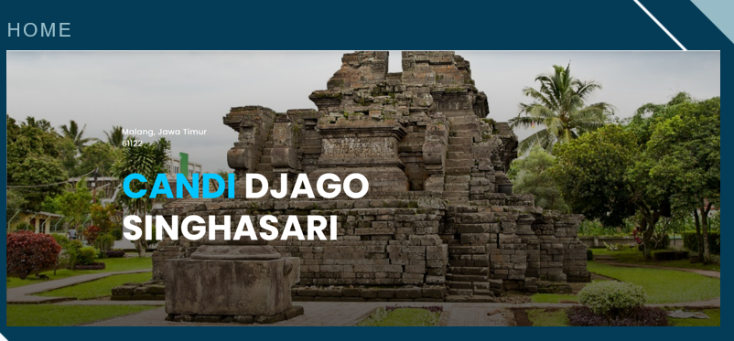

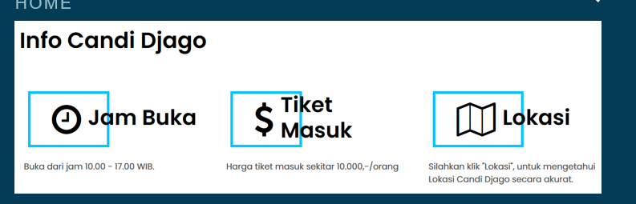

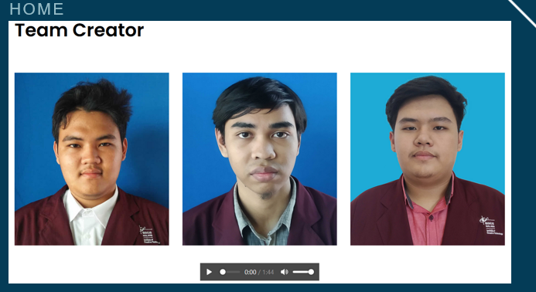

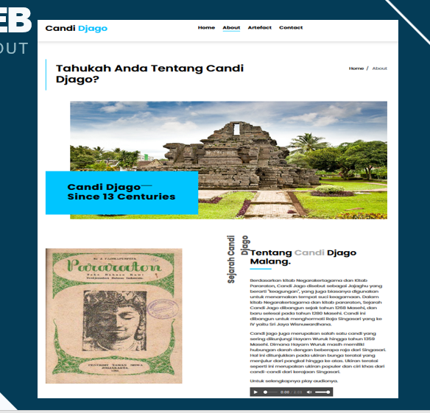

conclusion
Website can provide information or knowledge for someone to look for something so a website must really work according to the needs that can provide information. Reducing excessive expenditure of energy, A website appearance must reduce the appearance that makes visitors feel bored and use bright colors. Minimize fatigue, A website must minimize fatigue when people visit the website so that when the website is loading people don't take too long to wait for that website
The function of the website is an alternative means of delivering information. Information placed on various websites (eg knowledge, news, games, advertisements). Factors of the need to use the website include: a) Ease of distributing information to the general public (not limited by space and time); b) Speed of delivery of up to date information; c) The information conveyed is more interactive than other media.
Based on the results we have worked on, we have gotten quite satisfying results. It is proven that our website has a pretty good interactive. We hope that this website will help readers to know the history of the famous temples in Malang, East Java.

References
- Primadia, A. (2018, October 31). Sejarah Candi Jago Malang Lengkap Beserta Penjelasannya. Retrieved June 10, 2020, from https://sejarahlengkap.com/bangunan/sejarah-candi-jago
- Hadi, D. (2016, March 05). Pengertian Dan Cara Menggunakan Bootstrap. Retrieved June 10, 2020, from https://www.malasngoding.com/pengertian-dan-cara-menggunakan-bootstrap/
- Dipublikasikan oleh: Kardinata - (24 November 2019), K. (2019, November 24). Pengertian dan fungsi HTML, CSS dan Javascript sebagai pembangun Halaman web. Retrieved June 10, 2020, from https://www.wiblogger.com/2019/11/pengertian-html-css-javascript.html
- 3. (n.d.). HTML. Retrieved June 10, 2020, from https://www.w3schools.com/
- Hadi, D. (2018, October 09). Membuat Slider Responsive Dengan CSS. Retrieved June 10, 2020, from https://www.malasngoding.com/membuat-slider-responsive-dengan-css/

